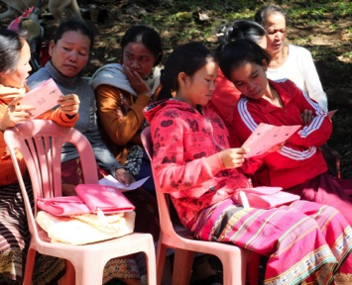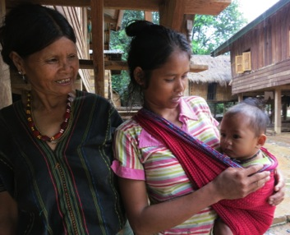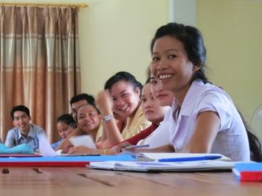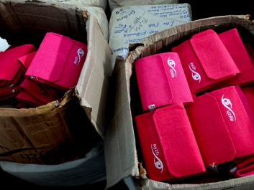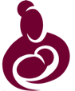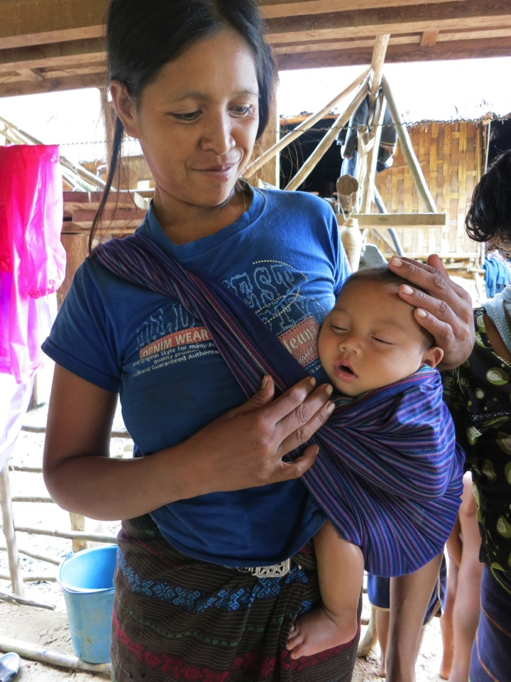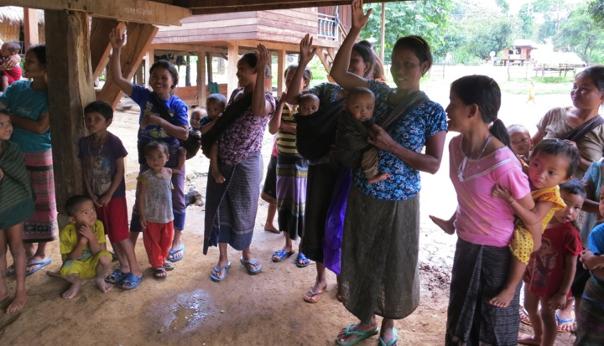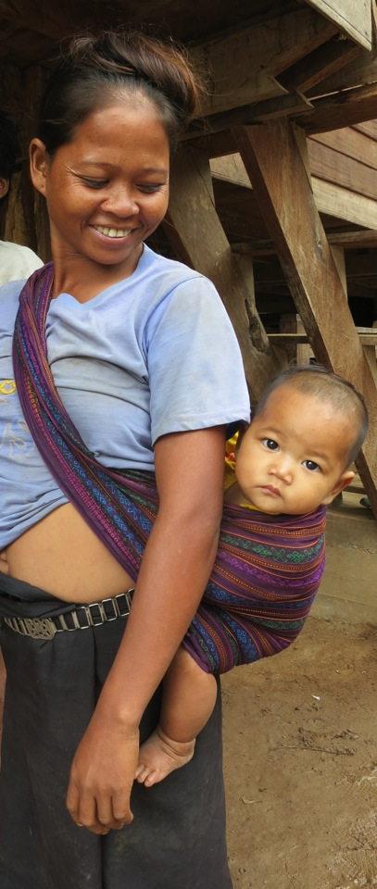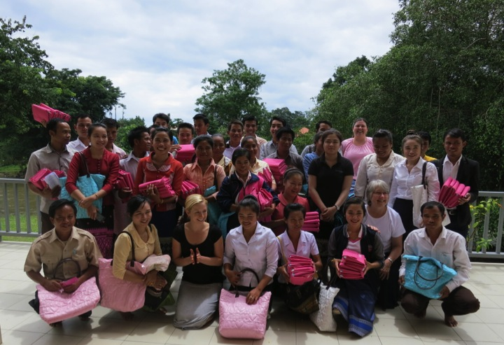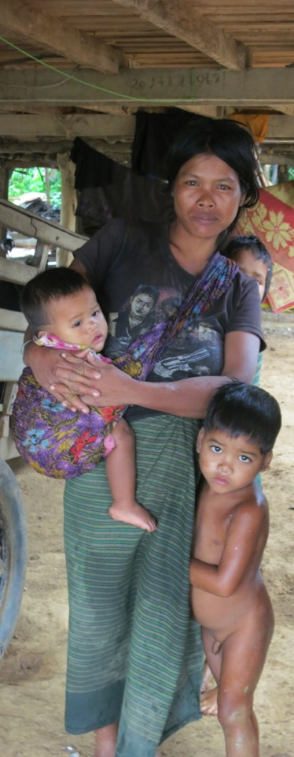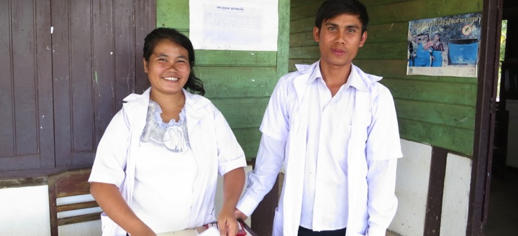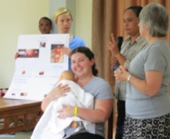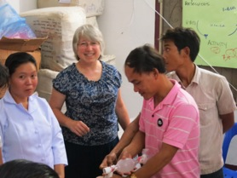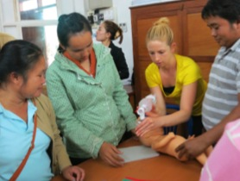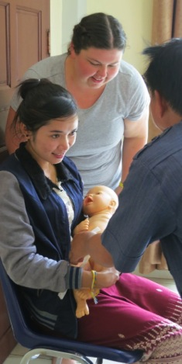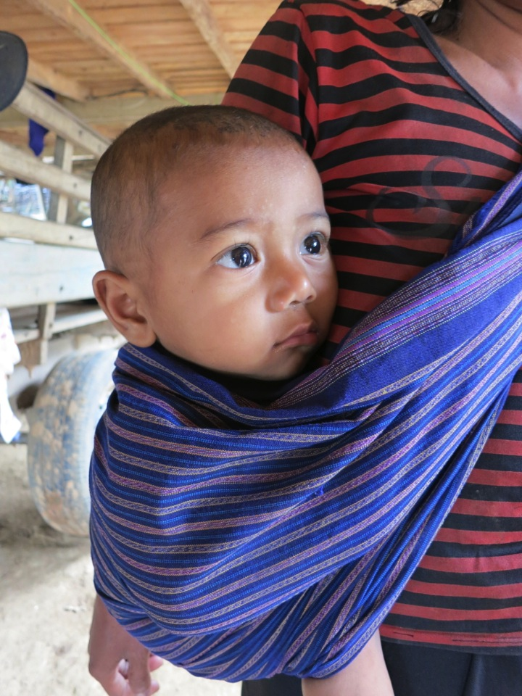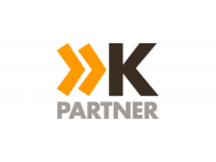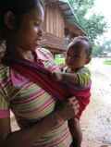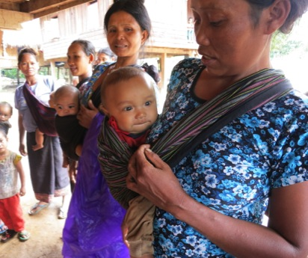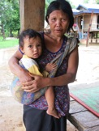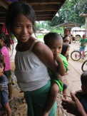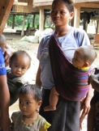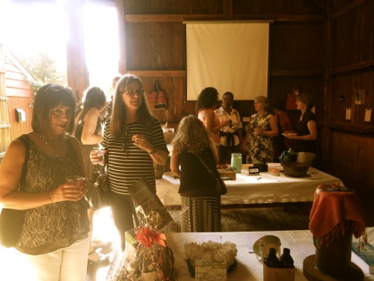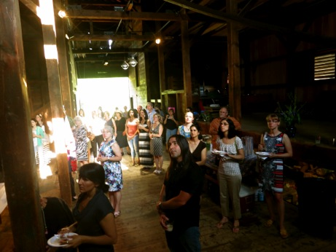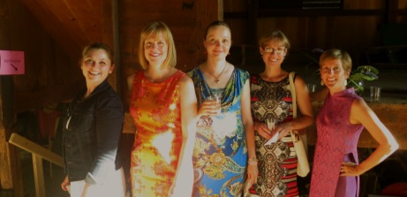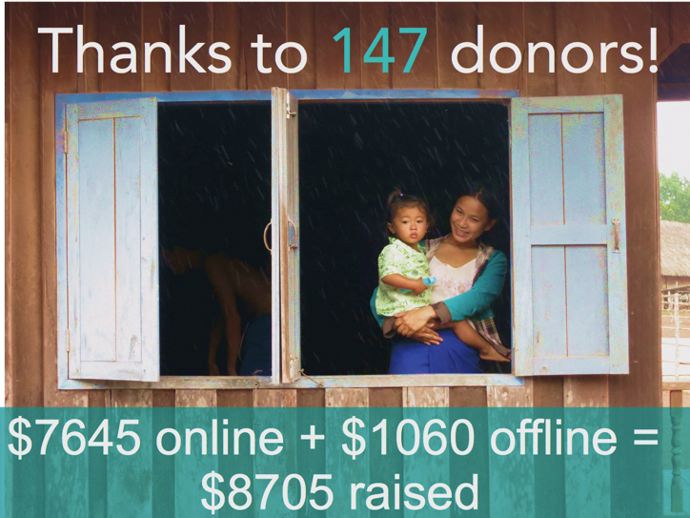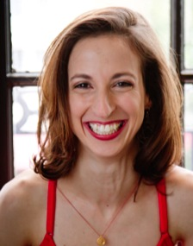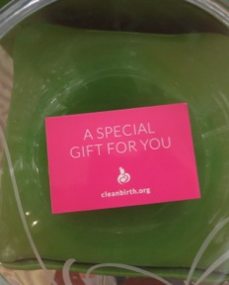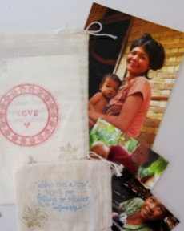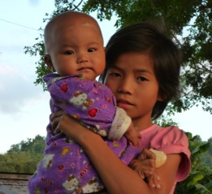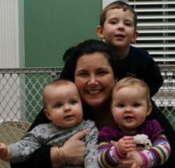

In 2014, our second full year, CleanBirth.org has grown dramatically.

☑ Our data shows that 1524 moms and babies had safer births with ZERO reported cases of infection.

☑ We trained 88 nurses, local staff and volunteers in Laos, triple the number of nurses trained in 2013.

☑ We have formed a productive alliance with the Yale School of Nursing.

☑ We received our official 501c3 tax exempt status.

A Year of Growth

CleanBirth.org

2014 Annual Report

**CleanBirth.org is a non-profit organization committed to making birth safer in Laos.**

We empower nurses to provide women in their communities with ayzh Clean Birth Kits and safe birthing education. We support our non-profit Lao partner in their local management of programming, training and distribution of birth kits. We listen to needs on the ground and fulfill them to the best of our ability.

## 762 moms. 762 babies. And the data to prove it.

We have hard data from nurses showing that 762 mothers received Clean Birth Kits and training in 2014.

Of those 762 who received a kit, 489* were interviewed by nurses after birth to ensure that kits were used correctly.

The post-partum data shows that ZERO moms or babies contracted an infection.

*Distance, weather prevented 100% interview rate. To get good data, we have focused on training nurses and especially our Lao partner, ACD, in Monitoring & Evaluation (M&E) procedures. Together with our Lao partner we developed M&E goals that are simple, practical and achievable.

Our data collection tools measure if: 1. Mothers receive a birth kit

2. Nurses are able to teach mothers how to use a birth kit.

3. Women have a birth helper

4. Clean techniques used at birth.

*

# A Show of Hands

+

2014 RESULTS:

Total # kits delivered to partner HQ:

2000

Moms & Babies who had safer births in 2014:

1524

Cases of infection reported:

0

2014 TRAINING:

Nurses, staff, volunteers trained

88

Full training days conducted

15

2014 INTERVIEWS:

Pre-delivery interviews by nurses:

762

Postpartum interviews by nurses:

489

Texts messages from nurses to partner HQ:

450

In July 2014, when we returned to train new nurses, we asked the 15 nurses we had trained in 2013, how we could improve the kits. Here is what they said:

|  |  |  |
| --- | --- | --- |
| Challenge | Solution/ Add-on to Kit | Implemented |
| Despite education by nurses about importance of having a birth helper, many women were still birthing completely alone. | Add gloves. Not for hygiene but so that helpers will have a blood barrier. Touching blood at birth is considered potentially harmful. | ✔ |
| Mothers lack clean cloth to swaddle newborns. | Add a second absorbent sheet. | ✔ |
| Mothers ask for a second clamp b/c they usually tie cord in 2 places. | Add a second cord clamp. | ✔ |
| The picture instructions should be real – not drawn –photographs of real people using the items in kit. | Add a new instruction sheet with real pictures of real people using the items in kit. | ✔ |

## Local nurses are best to foster lasting change.

# We listen to them.

This year saw the beginning of a wonderful partnership with the Yale School of Nursing.

A Yale team, led by Yale Professor and Midwifery Specialty Coordinator, Dr. Cecilia Jevitt, *CNM, PhD, FACNM*, traveled to Laos with CleanBirth.org in July 2014 -- adding significantly to the knowledge and skills we offer to local nurses.

Yale midwives taught the nurses the WHO’s Essentials of Newborn Care: clean birth, newborn resuscitation, skin to skin, basic newborn care and breastfeeding. The training was hands-on and effective – the nurses had many questions and were eager to learn.

We are grateful that the Yale School of Nursing funds 75% of the trip, with the participants paying the remaining 25% themselves.

We look forward to another fruitful training in March 2015.

Yale School

of Nursing

Our

Donors

Everything we do is made possible by YOU!

The amount of donations received during our crowdfunding, Mother’s Day and Holiday campaigns & at our Barn Party Fundraiser grew substantially in 2014.

Thank you!

CleanBirth.org was honored to be chosen as a Kopernik partner and receive $4,781.00 from Kopernik donors. Kopernik is dedicated to ensuring life-saving technologies like Clean Birth Kits make it the hard-to-reach “last mile.”

Without you, some of these babies might not have survived

+

Our Barn Party Raised $5000!

A warm June evening under the storied eves of the Eli Whitney Barn was the perfect setting for our 2nd Annual Barn Party! Nearly 100 supporters came to learn about our work and bid on Silent Auction items, that were donated by local artists, businesses and friends. Big thanks to the Eli Whitney Museum New Haven, CT for the venue.

Our largest fundraiser of the year, we were privileged to have the support of 147 donors from the world over: Australia, Thailand, Russia, France, Canada, and the USA to name a few.

# Crowdfunding.

/’kroudˌfəndiNG/ noun: the practice of funding a project by raising many small amounts of money from a large number of people, via the Internet.

Thanks to Pinterest, our Baby Shower Hostess Cards got attention in 2014. Several Baby Showers featured our Baby Shower Favors. Thanks! We plan to continue to build on these niche card markets in 2015.

BABY SHOWERS

BIRTHDAY GIRL

Michelle Cohen, a doula & yoga instructor in D.C, asked for CleanBirth.org donations for her birthday. Then she doubled the donations for a total of $640! Why? “I am passionate about supporting and empowering women through birth and into the postpartum phase, and I really wanted to give back as gratitude for all the amazing work I get to do!”

# Creative way to give.

## Special occasions & CleanBirth.org

HOLIDAYS

More and more donors are choosing our Holiday & Mother’s Day Cards: thoughtful eCards, beautiful hand-stamped bags, containing an honor card, or convenient printable cards. Using card-buying dollars to save lives is a win win! <http://cleanbirth.org/holiday-card-shop/>

+

Read why just three of our amazing donors give.

Donor Profiles

"I think that CleanBirth.org is an incredible organization with a clear mission on improving maternal health in parts of the world where having a baby can mean death for some women.  Their mission by extension supports families helping to keep them intact.  Kristyn is an inspiring leader whom I admire and respect for her commitment and dedication to this very important cause."

Carol Juel, EVP and Chief Financial Officer Synchrony Financial

“One of the deepest reasons I support Cleanbirth.org is that I would have died without the medical care I had delivering my first child, due to hemorrhaging. The world falls short in many places around the globe on such bare necessities when it comes to giving birth such as clean supplies and a skilled midwife. All mothers deserve access to those things -- Cleanbirth.org helps make that happen and saves lives. It's a no-brainer. Count me in!”

Jennifer Burden

Founder, World Moms Blog

I've attached a picture, not of myself, but of why I donate to CleanBirth. Look into the baby and the girls face. It says it all. Bringing health and care to mothers and infants through one committed organization is a beautiful opportunity for giving.”

Charles Powell, 5 time donor

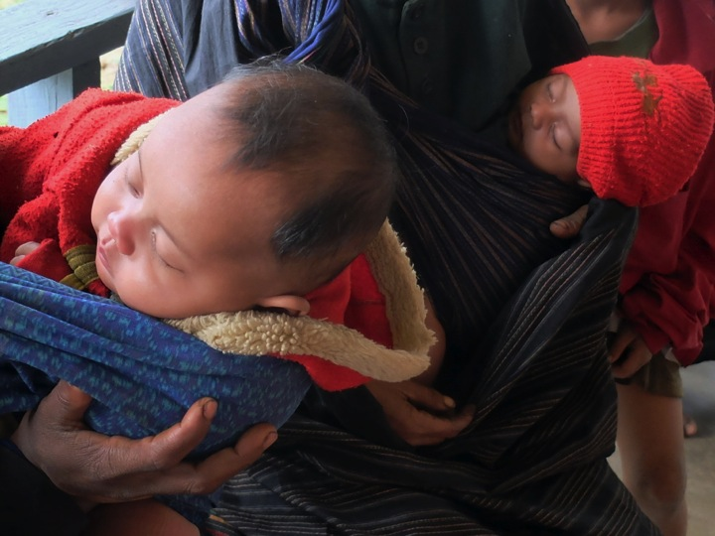

In 2014, we raised $20,939 and spent $20,623.

85.3% was spent on programming.

We received in kind donations from Yale Nursing for Yale midwives to travel to Laos ($7,000) and Kopernik for birth kits ($4,781).

No US staff was paid.

Finances

Volunteers

Kelley Gary

Susan Clinard

Anna Festa

Dee Warren Harlow

Khadija Hussain

Holly Jermyn

Marla Katz

Marcella Kovac

Donna Luangmany

Jenny Thepsombath

Marcella Kovac

Board of Directors

Kristyn Zalota

Max Zalota

Jenny Fouracre

Shannon Lawton O’Boyle

Contact us:

203.440.7145

kzalota@cleanbirth.org

17 Post Ave. Westbrook, CT

06498

Supporters

World Moms Blog

Multicultural Kid Blogs

Girls Globe

ayzh

Cultur Baby

maternova

Allinder-Anestis Family Charitable Fund

Kopernik

Yale School of Nursing